HW Connections
- GPIO adapter DPNC422_06A is connected on GPIO J17, J18 is left unconnected. If wrong connection done, will burn the F4 fuse (3V3) and might damage the GPIO board.
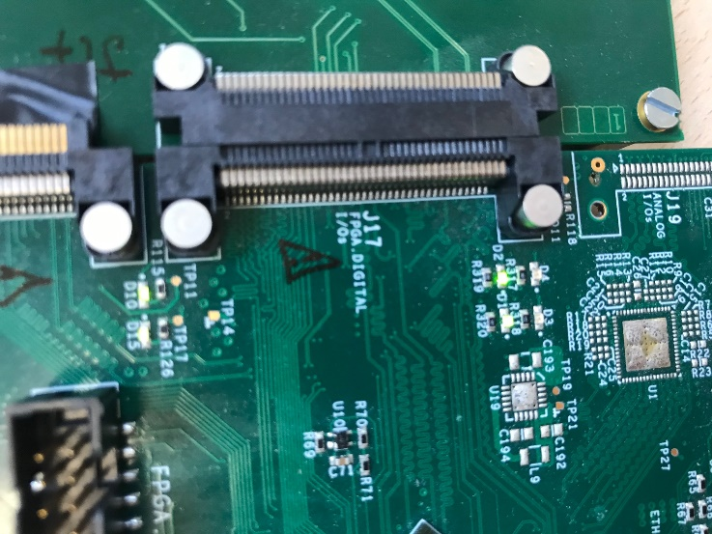
- Connect FIREFLY to DPNC422_06A FRB0 slot and to FRB Power Board connector small flying board
- Connect PS cords to PS and FRB power board small flying board:
  - +/-3V4 + GND cable to PS with black wire on the middle point = GND of dual PS
  - +/-5V7 + GND cable to PS with black wire on the middle point = GND of dual PS
  - +12V + GND cable on PS
  - For the +/-3V4 and +/-5V7 cables, take care of same connector on Power board small flying board, look at labels.
  - It is not mandatory to connect all middle points of +/3V4, +/-5V7 and 12V GND together.
  - Do not connect PS earth to middle point / GND

Power supply start
- Power on +/-5V7, +/-3V4 and 12V at the same time
- Then the GPIO 24V
Consumption:
Voltage | +5V7 | -5V7 | +3V4 | -3V4 | +12V | +24V
Typical Current (mA) | 187 | 30 | 497 | 12 | 4

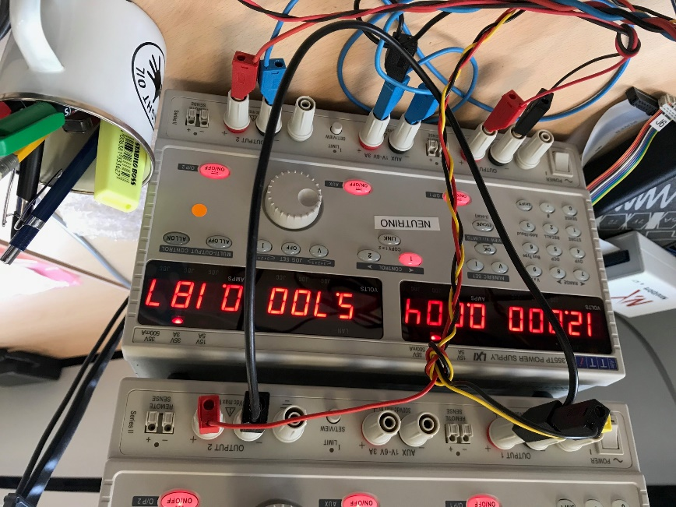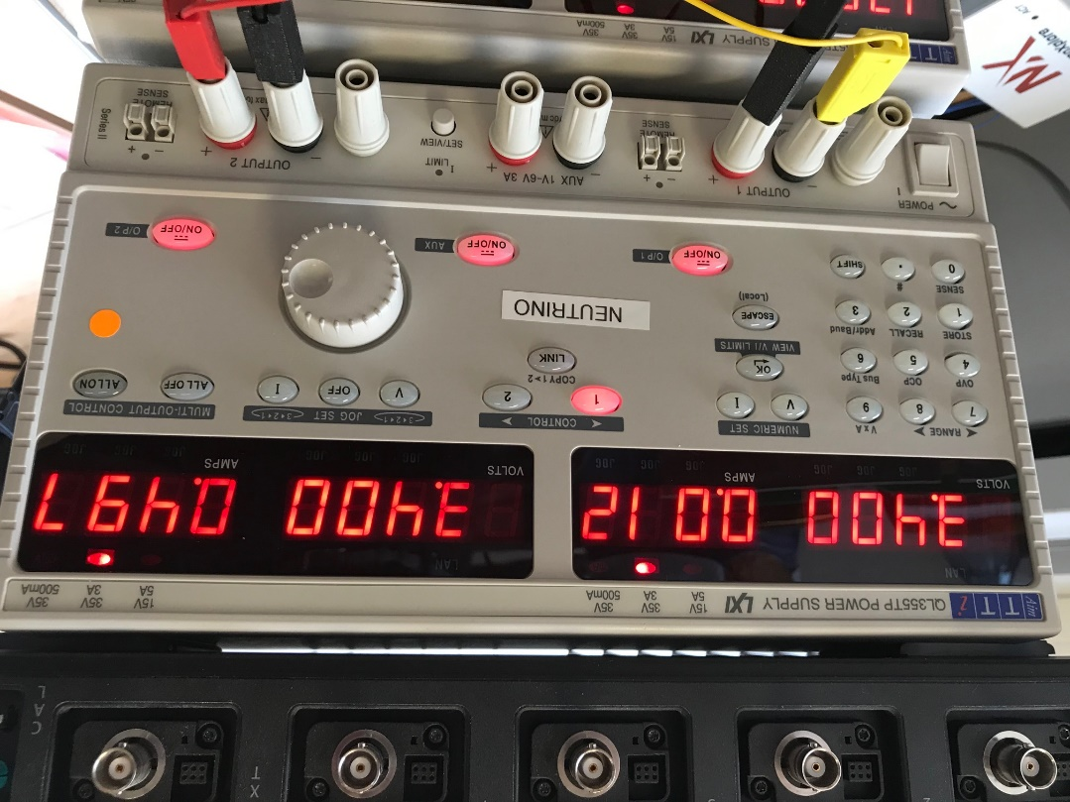

The GPIO front end .exe files are located on http://dpnc.unige.ch/~favrey/Misc/Herd/HerdFrontEnd-FEB/
Once started, the GUI should display the version 6/0.1/8/0.
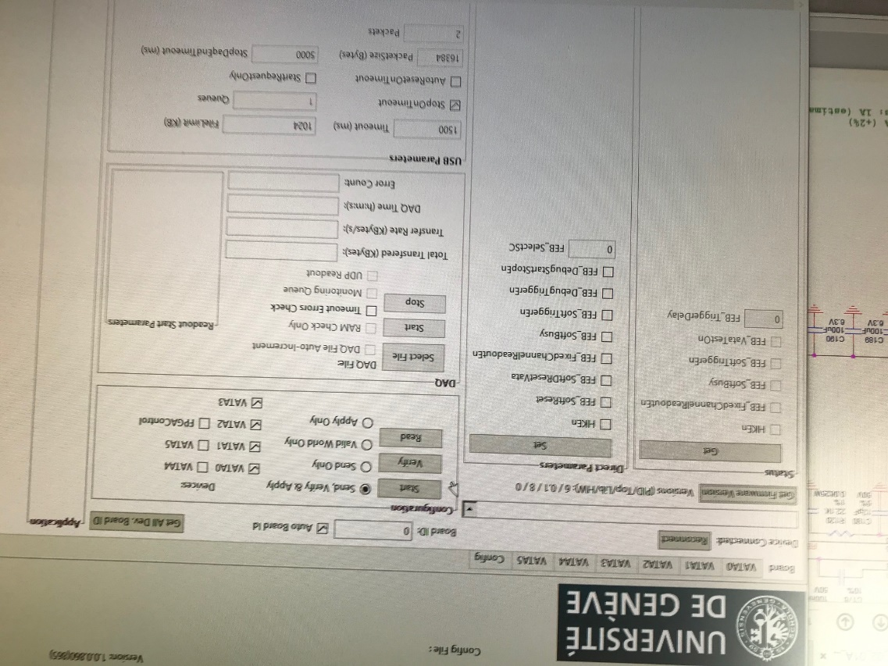

Protocol
31 | 30 | 29 | 28 | 27 | 26 | 25 | 24 | 23 | 22 | 21 | 20 | 19 | 18 | 17 | 16 | 15 | 14 | 13 | 12 | 11 | 10 | 9 | 8 | 7 | 6 | 5 | 4 | 3 | 2 | 1 | 0
#EVENT (6b)  Range 0-63 |  |  |  |  |  | #FEB (5b)  Range 0-17 (0-3 now) |  |  |  |  | #CH (9b)  Range 0-383 |  |  |  |  |  |  |  |  | ADC VALUE (12b)  Range 0-4095
0 |  |  |  |  |  | 0 |  |  |  |  | 0 |  |  |  |  |  |  |  |  | 0x112 |  |  |  |  |  |  |  |  |  |  |  | 4 FEBs  x  384 CHs  =  1536 word32  per  event
0 |  |  |  |  |  | 0 |  |  |  |  | 1 |  |  |  |  |  |  |  |  | 0x121 |  |  |  |  |  |  |  |  |  |  |  | 4 FEBs  x  384 CHs  =  1536 word32  per  event
0 |  |  |  |  |  | 1 |  |  |  |  | 0 |  |  |  |  |  |  |  |  | … |  |  |  |  |  |  |  |  |  |  |  | 4 FEBs  x  384 CHs  =  1536 word32  per  event
0 |  |  |  |  |  | 1 |  |  |  |  | 1 |  |  |  |  |  |  |  |  | … |  |  |  |  |  |  |  |  |  |  |  | 4 FEBs  x  384 CHs  =  1536 word32  per  event
0 |  |  |  |  |  | 2 |  |  |  |  | 0 |  |  |  |  |  |  |  |  | … |  |  |  |  |  |  |  |  |  |  |  | 4 FEBs  x  384 CHs  =  1536 word32  per  event
0 |  |  |  |  |  | 2 |  |  |  |  | 1 |  |  |  |  |  |  |  |  | … |  |  |  |  |  |  |  |  |  |  |  | 4 FEBs  x  384 CHs  =  1536 word32  per  event
0 |  |  |  |  |  | 3 |  |  |  |  | 0 |  |  |  |  |  |  |  |  | … |  |  |  |  |  |  |  |  |  |  |  | 4 FEBs  x  384 CHs  =  1536 word32  per  event
0 |  |  |  |  |  | 3 |  |  |  |  | 1 |  |  |  |  |  |  |  |  | … |  |  |  |  |  |  |  |  |  |  |  | 4 FEBs  x  384 CHs  =  1536 word32  per  event
0 |  |  |  |  |  | 0 |  |  |  |  | 2 |  |  |  |  |  |  |  |  | … |  |  |  |  |  |  |  |  |  |  |  | 4 FEBs  x  384 CHs  =  1536 word32  per  event
0 |  |  |  |  |  | 0 |  |  |  |  | 3 |  |  |  |  |  |  |  |  | … |  |  |  |  |  |  |  |  |  |  |  | 4 FEBs  x  384 CHs  =  1536 word32  per  event
0 |  |  |  |  |  | 1 |  |  |  |  | 2 |  |  |  |  |  |  |  |  | … |  |  |  |  |  |  |  |  |  |  |  | 4 FEBs  x  384 CHs  =  1536 word32  per  event
0 |  |  |  |  |  | 1 |  |  |  |  | 3 |  |  |  |  |  |  |  |  | … |  |  |  |  |  |  |  |  |  |  |  | 4 FEBs  x  384 CHs  =  1536 word32  per  event
0 |  |  |  |  |  | 2 |  |  |  |  | 382 |  |  |  |  |  |  |  |  | … |  |  |  |  |  |  |  |  |  |  |  | 4 FEBs  x  384 CHs  =  1536 word32  per  event
0 |  |  |  |  |  | 2 |  |  |  |  | 383 |  |  |  |  |  |  |  |  | … |  |  |  |  |  |  |  |  |  |  |  | 4 FEBs  x  384 CHs  =  1536 word32  per  event
0 |  |  |  |  |  | 3 |  |  |  |  | 382 |  |  |  |  |  |  |  |  | … |  |  |  |  |  |  |  |  |  |  |  | 4 FEBs  x  384 CHs  =  1536 word32  per  event
0 |  |  |  |  |  | 3 |  |  |  |  | 383 |  |  |  |  |  |  |  |  | … |  |  |  |  |  |  |  |  |  |  |  | 4 FEBs  x  384 CHs  =  1536 word32  per  event
1 |  |  |  |  |  | 0 |  |  |  |  | 0 |  |  |  |  |  |  |  |  | …
1 |  |  |  |  |  | 0 |  |  |  |  | 1 |  |  |  |  |  |  |  |  | …

