ND280 Upgrade Grounding and Shielding

Purpose and Scope
The ND280 Upgrade contains three major sub-detectors (HAT, sFGD and TOF) with numerous electrical and electronic entities in two major physical locations, all of which have the potential to electrically interfere with one another. Furthermore, the areas immediately surrounding the ND280 detector itself have additional electrical and electronic entities, including some motors and other fairly high power entities that have some possibility of interfering with the electrical signals in the upgrade sub-detectors. It is the stated goal of this Grounding and Shielding Plan (GSP) to eliminate any such possibility. Specifically, this Plan establishes requirements and design principles to ensure that the various subsystems do not allow current flows or capacitive or inductive couplings that could cause such interference. Likewise, shielding is defined such that detector subsystems do not couple into one another by way of electric (capacitive) or magnetic (mutual inductance) modes and so that the subsystems are protected from external interference to the greatest extent possible. In addition, the plan extends somewhat beyond just “grounding and shielding” by defining “best practices” for device selection and device-to-device signaling to reduce the risk of internal interference from one device to another.

Overview
The three new ND280 upgrade detectors, HAT, sFGD and TOF all reside in a “basket” that will replace the original P0D detector at the upstream end of the UA1 magnet.
Maybe redundant with next figure…

Figure number + description and reference to this figure in the text… Maybe use only this figure and remove the previous one (redundancy)

This document is intended to detail a plan that will ensure that the upgrade detectors perform well and do not interfere electrically with any of the other systems in the ND280 detector complex. This sort of interference is normally referred to as electro-magnetic interference – EMI. There are two main ways in which one electrical object, the aggressor, can interfere with another electrical object, the victim – capacitive and inductive coupling. In general there are a number of methods that can be used to reduce or eliminate both types of coupling. For capacitive coupling, perhaps the easiest to understand, one can readily reduce the capacitance between aggressor and victim and thus directly reduce the effect of the coupling. This reduction in capacitance can be obtained by increasing distances, by reducing areas, by reducing the dielectric constant of intervening material and by shielding. Of course only careful shielding can reduce the capacitance to near zero but the other methods can still be very useful when shields are difficult or expensive to implement. For inductive coupling increasing separation between conductors can have significant impact as can interposing low impedance grounded (actually at any convenient potential) conductors. However, the dominant inductive effects are, generally, between loops of conductor as, for instance, where an aggressor signal is more effectively sensed by a victim conductor if that conductor forms a loop and thus acts as an antenna. It is more difficult to shield against inductive interference, especially at lower frequencies, as an effective shield must have a low magnetic impedance as well as a low electrical impedance. For instance, a high quality commercial shielded room uses not only layers of copper but also of soft iron and/or mu metal. Such construction is not often possible in the context of a large particle detector. However, one technique that is very effective against inductive coupling is the use of twisted pair cables for large swing digital signal transmission. The twists mean that the loop area of the signal (whether an aggressor or victim) is very near zero since half the twists are pointed in a direction opposite from the other half. For this reason, long cables carrying digital traffic should, in general, be twisted pair with a true differential signaling drive such as LVDS.
There is also the common impedance coupling which plays a major role in noise injection. I don’t want to enter in to too many details about EMI but to be purist if you want to introduce some EMI concepts: there are no less and no more than 6 couplings based as you say from inductive or capacitive coupling for 5 of them but the 6th, common impedance coupling, is based on ohm law. Here are the 6 coupling types:
- Common impedance coupling (DC and AC circulating current)
- Board to chassis coupling (AC voltage circulating in parasitic capacitor between chassis/ground or/environment and board)
- Inductive coupling between conductors (AC current circulating in the mutual inductance between aggressor and victim)
- Capacitive coupling between conductors (AC voltage circulating in the parasitic capacitor between aggressor and victim)

- Variable electrical field to conductor (AC E field to antenna wire / electric)
- Variable magnetic field to loop (AC H field to antenna loop / magnetic)
See p.8 of my EMC basics presentation…
I think you should put guidelines for the sub-detector G&S design:
Guidelines:
Architecture:
Each sub-detector should provide a grounding and shielding scheme showing the electrical architecture including sensors, electronics (frontend electronics, amplifier stages, backend electronics) and their signals, (cable, shield), chassis, ground connections (boards, chassis, cabinets).
Electrical cabling:
It is crucial to connect both ends of each cable shield to the ground (i.e. ground of each equipment located on each side of the cable) which is this so-called mesh ground. This is essential since a cable shield connected only on one end sees it performances degraded by 80 to 40 dB at f>1MHz (see p.18/19 of my presentation), knowing that power supplies, relays, motors, etc… can pollute a lot at these frequencies. Since it is almost impossible to reject high frequencies with amplifiers or regulators (CMMR degrades as frequency increases), shielding on both ends is the only way to achieve a good rejection.
To summarize, a coaxial with a shield connected on both ends is very good for HF signals, but not for f<100Mhz, that’s basically why it is used for HF. A shielded twisted pair with a shield connected on both ends is very good in all frequencies since the twisted pair and the differential amplifier will reject easily any LF noise and the shield any HF noise. As a conclusion, LF signals must be propagated on shielded twisted pairs. NB: the shield acts not only on any antenna effect (Coupling 5 or 6) but majorly on common impedance coupling.

Another important thing for cables is the distance to the mesh ground which must be reduced as short as possible to reduce the ground loops. Putting cables in metallic trays connected on both ends and on several points along the distance to the mesh ground is a safe solution. Moreover, the trays will reduce the common impedance coupling by adding ‘more mesh’ to the common ground, i.e. improving the total EMC.
As a rule, any cables going in or out of a sub-detector should be clearly identified with its properties (voltage/current, signal bandwidth, type of cable used and path description) to see whether it meets the previous guidelines.
NB: A very good test for EMC is the 61000-4-4 standard (fast burst transient) for cable greater than 1m long. Passing this test for a sub-detector guaranties a very good robustness to the environement.
Power supplies:
It is crucial to control the signal return path of any power supplies (the 0V of a 5V/0V power supply for instance) in order to avoid a return current through the structures. Thus, a single connection point for each Power supply 0V must be made at the load side only (see p.35/36 of my presentation), and the PS must be DC insulated from the chassis. An AC coupling with a capacitor to the PS chassis can be made reduce the HF noise.

Original ND280 Plan
Unfortunately it does not seem that any single grounding and shielding document that summarized the approach taken toward ameliorating this problem was created during the original ND280 construction. However, there are many notes and talks covering the subject that were created during the design period and these have been collected here (where do we want to put the bits and pieces that Thorsten and Alfons and Martin have found??). From those notes and later discussions (especially with Alfons Weber) it does seem clear that the general philosophy was to create a “mesh” ground – that is cross connect all the electrical elements of the detector with as low an impedance mesh of connections as reasonably possible (including wide copper sheet connections) so the potential differences between regions of the system, including the DAQ and trigger systems located on the SS level, were small across the relevant region of frequency space. The success of the ND280 detector over the past decade indicates that this effort was largely if not entirely successful.
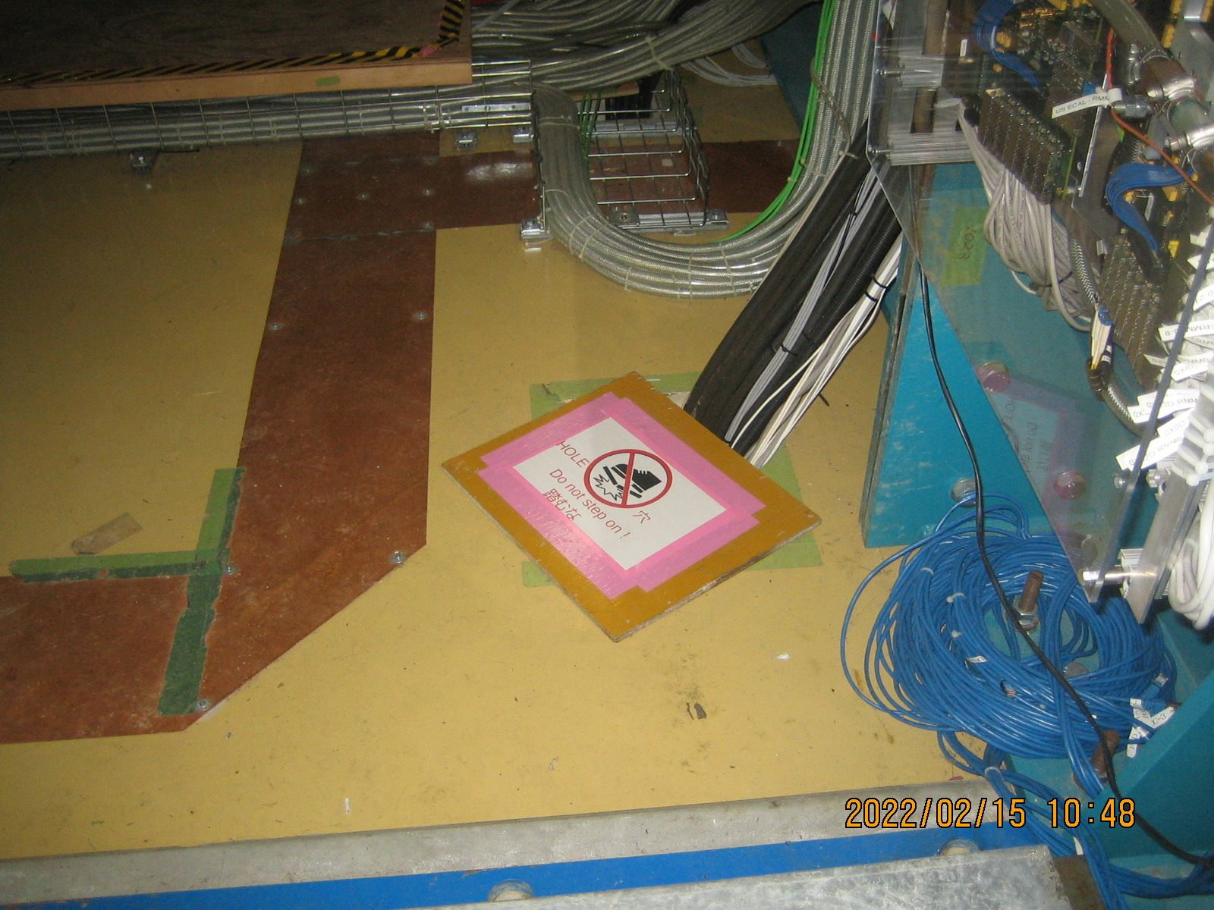
Figure number + description and reference to this figure in the text…
So for the upgrade, the “ground”, at least, is well defined – it is the metal, both structural and connective like the copper sheet system of the present ND280 system. Our only challenge is to be certain that we connect the upgrade basket well to the existing mesh.

Regions and Sub-Detectors
There are three different sub-detectors in the ND280 upgrade, the sFGD (super fine grained detector) residing in the middle of the new basket in the upstream center of the magnet, the HAT (high angle TPCs) sitting above and below the sFGD and the TOF (time of flight) layer with six panels surrounding the HAT-sFGD detectors in an almost hermetic fashion. All of these detectors and their on-detector electronics are contained in the metal (steel??) installation basket which is mechanically and, thus, electrically, firmly attached to the original surrounding structures. [question – how well attached, do we connect with the copper sheet system???] However, many of the services (gas, cooling, low and high voltage power, trigger, timing and DAQ) for these sub-detectors are located in relay racks or skids on the SS floor, immediately below the hall with the magnet. There are many cables and pipes that run between the SS floor and the actual detectors and all of these service lines are, potentially, aggressors or victims or could create unwanted connections and so must be dealt with carefully.

Figure number + description and reference to this figure in the text…
What is the purpose of this figure which helps for G&S ? Or put labels / arrows to explain something helpful for G&S showing areas / detectors …
Put floors/levels that are cited in the text after …

High Angle TPC (HAT)
Each of the two HAT is composed of a 1 m x 2 m x 2 m gas tight field cage made of two identical halves joined together around a vertical cathode plane that is brought to a high potential. On the four internal walls of the field cage, copper strips etched on Kapton foils are interconnected by precision surface mount resistors to make an electric field degrader, bringing the potential to zero at each extremity plane of the field cage. The two end-plates of each HAT are instrumented with eight Embedded Resistive Anode Micromegas detectors (ERAM). A schematic view of a HAT is shown in Figure 1.
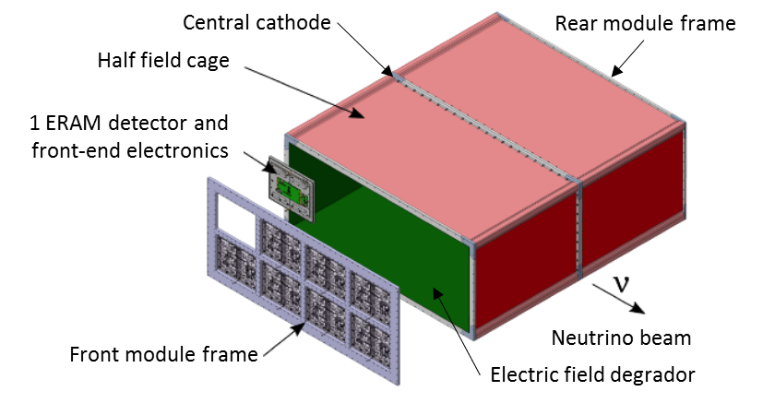
- One of the two HAT.

Each ERAM detector is segmented into 32 x 36 pads which are read out by front-end electronics directly plugged at the back of the detector module. The analog signals delivered by the ERAMs are electric charges of only few tens of fC. It is therefore crucial that no internal or external perturbation is induced on the ERAM detectors and the analog part of the readout electronics of the HAT. Obviously, the HAT sub-system must also limits its own electromagnetic emission footprint to avoid risks of interferences with the sFGD, the TOF and the other sub-detectors installed close by in the UA1 magnet.
The elements within the HAT sub-system that have to be scrutinized include: the high voltage power supply and distribution cabling to each central cathode, the high voltage power supplies and distribution cabling to the ERAM detectors, the ERAM detectors themselves, the low voltage power supply and distribution cabling to the front-end electronics, the front-end electronics itself, slow-control circuits and cabling. To some extent, gas pipes inlets and outlets for the field cage, the water cooling circuit for the front-end electronics, and the back-end electronics also have to be analyzed.
The baseline grounding strategy is to replicate the one of the ND280 vertical TPCs tracking system with a common ground for ND280 basket, HA-TPC mechanical structure, ERAM modules and readout electronics. (TbC : is this common ground connected to clean ground in the Pit ? )

Architecture of G&S
TODO

Central cathode, high voltage power supply and cabling
The.

ERAM modules, high voltage power supplies and cabling
The ERAM modules are the assembly of an ERAM detector, a Printed Circuit Board (PCB) glued on an aluminum stiffener with the Front-End readout electronics cards (see 5.3) and a water cooling copper pipe called "serpentin". The ERAM detector, 328 microns thick, is built up on one side of the PCB with a DC polarized resistive layer at a nominal voltage of 350 V (the Diamond-Like-Carbon layer isolated by a 50 microns thick Kapton layer) and a grounded stainless steel woven mesh 128 microns above the DLC. The PCB ground, the woven mesh, the aluminum stiffener, all the Front-End Electronics, the water cooling serpentin pipe, and the grounded shields of the HV and LV coax cables are connected and therefore at the same "mechanical" ground equipotential defined by the two HA-TPC aluminum Module Frames (endplate) and the HA-TPC field cage. Two patch panels on both sides of a Module Frame each connect four of the "on Module Frame" 1.5 m long HV cable (TYPE OF SIGNAL and CABLE?) with the "HA-TPC" 28 m long external cables (TYPE OF SIGNAL and CABLE?) going out of the ND280 basket to the HV Power supply hosted in one of the 2 HA-TPC racks at Service level. The metallic patch panel is at the same ground as the module frame and the HV shield coax ground. An HA-TPC Module frame fully equipped and functional with ERAM modules and mounted on the HA-TPC mockup is shown on figure 2 for illustration (final cable paths will be optimized and cables better fixed than with tape).
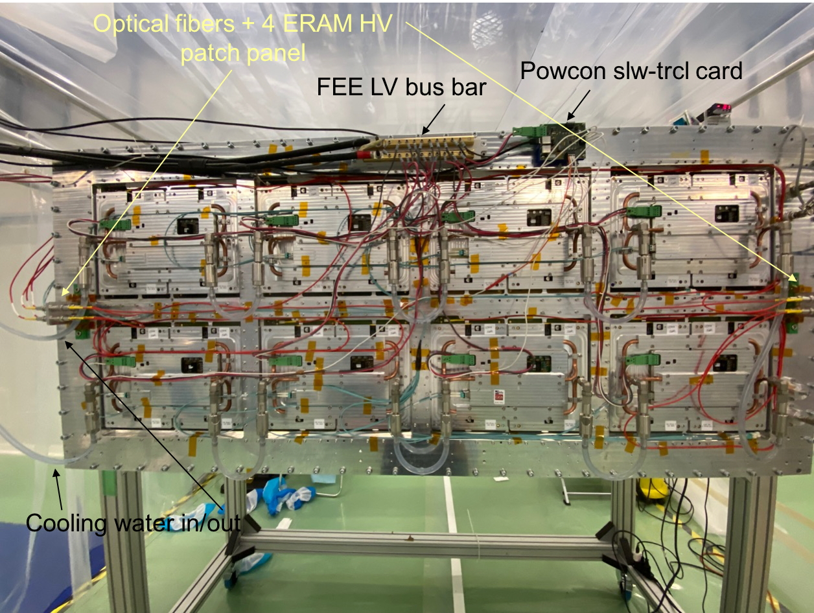
- Complete and functional mockup of one of the 2 endplates (Module Frame) of an HA-TPC equipped with 8 ERAM modules.
The DLC layer of the ERAM detector is polarized at 350V through a shielded coax cable (ref: xx) which connect on the ERAM PCB backside the shield on the woven mesh and the core "hot" cable on the DLC (through 2 copper pads on the PCB). The HV power supply is composed of 4 ISEG 8 channels modules (ref: xx) hosted in a Wiener "mini MPOD" rack (ref:xx). The 4 ISEG HV modules can be configured for the 8 channels to be at the same common ground as the rack (CFG configuration) or at a Floating Ground (FG) separated from the rack ground. The baseline grounding configuration of the HV power supply is the CFG one, used for the ND280 vertical TPC (see figure 3).
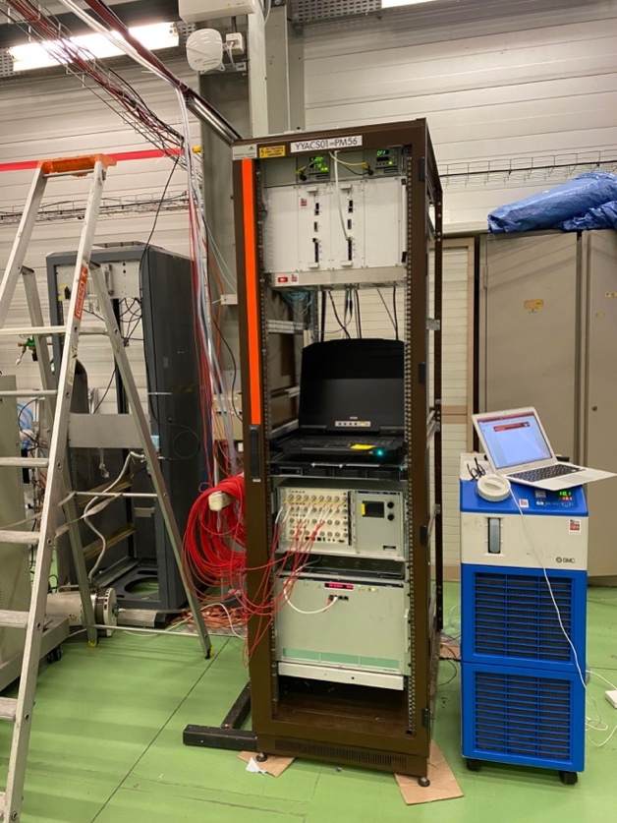
- One of the 2 HA-TPC racks filled with Backend TDCM Power supply, backend TDCM, DAQ/Slw-ctrl MIDAS PC, Mini-pod ERAM HV power supply and Wiener LV power supply (top to bottom).

Front-end electronics, low voltage power supplies and cabling
The readout electronics of each HAT is based on the replication of two types of electronic boards: the Front End Card (FEC), and the Front-End Mezzanine card (FEM). The FEC performs the amplification, shaping, sampling and analog to digital conversion of the signals delivered by an ERAM detector. A picture of a FEC is shown in Figure 4.

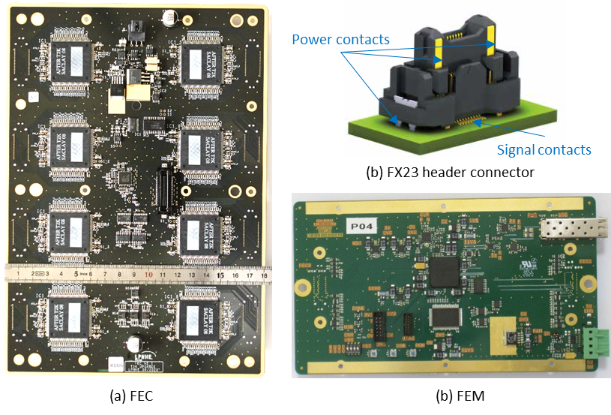
- (a) A FEC without its carapace. The eight connectors for plugging the FEC on an ERAM detector are placed on vertical columns at the rear side of the PCB. (b) Hirose FX23 header connector. Power and signal contacts are provided. Floating type headers and plugs are used respectively on the ERAM and FEC sides respectively, providing an increased floating range of ±1.2 mm in XY directions. (c) A FEM without its carapace. A FEM controls two FECs and plugs directly onto them using the same type of connectors that are used for the ERAM-FEC connections.
The main building block of the FEC is the AFTER chip, a 72-channel ASIC which was designed for the readout of the vertical TPCs in T2K nd280m. Each FEC houses 8 AFTER chips, leading to 576 channel per board. Two FECs are needed to read out the 1152 pads of an ERAM detector module. The connection between an ERAM detector and each FEC takes eight eighty pin connectors (floating type, series FX23 from Hirose). On each connector, eight of the surface mount type pins are assigned to ground, and the four power pins (through-hole type) of each connector pair are also tied to ground on the ERAM side and the FEC side. Each FEC is equipped with an aluminum carapace that comes in contact with a continuous ground ring made on the top layer of the PCB. The FEC and its carapace are screwed on the aluminum module frame that supports the ERAM detectors. The two FECs of an ERAM module are driven by a Front-End Mezzanine (FEM) card that performs all the digital electronic functions required to configure, synchronize and readout the FECs, and communicate via optical links with the back-end electronics that is placed at the floor below the UA1 magnet, over twenty meters away from the HATs. The top side of the FEM is covered by an aluminum carapace that acts as a shield, a heat sink, and provides mechanical protection. On the bottom side of the FEM, a thin layer of coppered FR4 is placed for shielding and dust / mechanical protection. The top side carapace of the FEM and the rear shield are electrically connected to the ground planes of the board via contact areas on the PCB and metallization around the mounting holes and screws. Additional screws connect the carapace of the FEM to that of each FEC and bring the ground reference planes of all the electronic cards mounted on the end-plate to a common equipotential.
The interconnection between the FEM and each FEC takes an 80-pin connector pair (FX23 family from Hirose, identical to those used for ERAM to FEC connections). Among the 80 surface mount pins of this connector, 22 are assigned to ground while 50 carry LVCMOS or LVDS signals, and 8 are not assigned. Two of the four through-hole pins of each FX23 connector pair between the FEM and a FEC are used to bring the external 5 V low voltage power supply to the FEC through the FEM, and the remaining two through-hole pins on these connector are tied to the ground plane of their respective board. On the FEM side, the +5 V terminal connected to the external power supply cable is connected to the main LDO regulator of the card (which provides 3.3 V) through a reverse voltage protection circuit and an eFuse, and it is connected in parallel to the connector pins that power the FECs. The current return cable is connected to the ground planes of the FEM and FECs, which are all brought to the same equipotential on the module frame via the carapaces of the cards and the mounting screws.

Low voltage power supplies for front-end electronics and power distribution
The front-end electronics placed on each HAT end-plate is composed of 16 FECs and 8 FEMs. In total, these cards consume approximately 35 A at 5 V. Power is delivered by a Wiener PL506 power supply unit that is placed in a rack at the SS level, below the floor where the UA1 magnet and HATs are located. The Wiener PL506 is a floating type power supply unit. It comprises eight independent, isolated, low voltage modules. Only four modules are used for powering the front-end electronics of the HAT (one low voltage module per HAT end-plate). The remaining low voltage modules are spares. A picture of the Wiener PL506 power unit is shown in Figure 5.
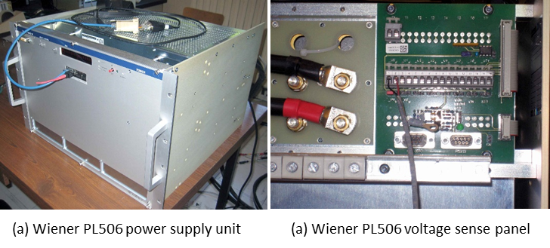
- (a) Wiener PL506 power supply unit. It is housed in a 7U x 19’’ rack-mountable enclose and comprises eight independent and isolated low voltage module 2-7 V / 115 A. (b) Main terminal studs and rear side panel for connecting voltage sense pairs.
The required length of cable between the power supply unit and the front-end electronics is expected to be between 25 m and 30 m. Low voltage power distribution cabling for the front-end electronics of the HAT is divided into two parts: a ~25 m long part made of large section cables which are common to all the modules of an end-plate, and 8 parts of smaller section cables bringing power to each individual module. The common part of the cable is composed of two 50 mm2 section insulated conductors (5 V supply and return current), one shielded twisted pair cable for sensing the voltage at the extremity of the cable, and one 1 mm2 section ground cable. These four cable components are bundled together by evenly spaces cable ties and heat shrinkable sleeves. A schematic view of the low voltage power supply cable assembly for an end-plate of a HAT is shown in Figure 6.
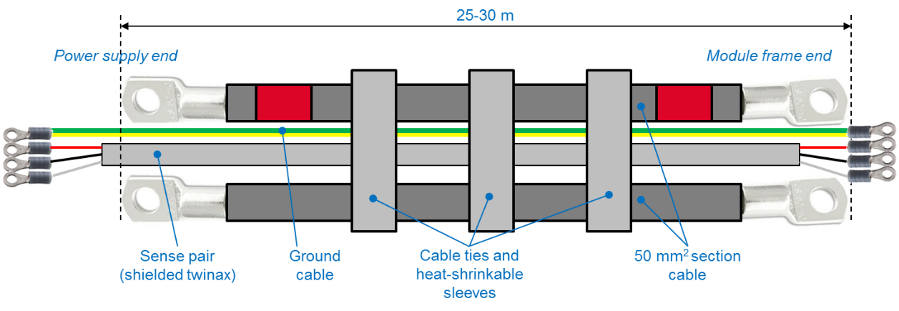
- Low voltage power supply cable for an end-plate of a HAT. The large section cable pair carry the current flow and return current. The twinax pair is used for sensing the actual voltage at the load extremity of the cable. A ground wire is added to the cable assembly.
On the power supply end, the 5 V supply cable and return current cable are connected to one of the modules of the PL506 unit. The two sense wires are connected to the corresponding sense inputs. The shield of the sense wire may be left floating, or could be connected to the ground chassis of the power supply, either directly, or via a capacitor or small value resistor. The same alternative applies to the ground wire. One module of the PL506 suffice to power the front-end electronics of an end-plate. The positive output terminal of each power supply module is therefore isolated from the others. On the other hand, the return current terminals may be left independent, or may be tied together. Experience with the vertical TPCs (that use comparable front-end electronics and the same model of power supply unit) showed that achieving low noise on detector channel could only be achieved by connecting the negative terminals of all the power supply modules in-use by copper braids. Tests to be made when the HAT are installed will show if the same strategy has to be applied for the HATs, or if all low voltage modules can be left entirely floating at the low voltage power supply unit end.
At the HAT end-plate extremity, the common section of the power supply cables is connected to a pair of distribution bars which are made of brass. Both power distribution bars are electrically isolated from the module frame structure. Each wire of the sense pair is connected to its respective power distribution bar while the shield is connected to the HAT module frame. The ground wire is also connected to the module frame. The power distribution bars receive the 8 low voltage cables pairs that bring power at the input connector of each of the FEMs of the end-plate. An additional low voltage cable pair brings power to the PowCon card, which is the device that individually controls the powering ON and OFF of each FEM. A picture of the power distribution bars mounted on the end-plate of a HAT is shown in Figure 7.
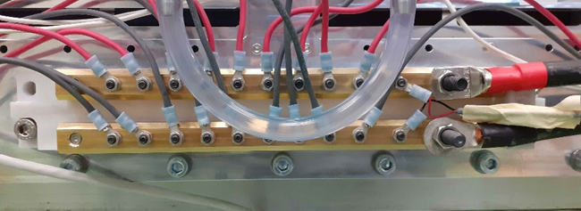
- Low voltage power distribution bars on a HAT end-plate. The sense wire are connected next to the main cable terminals. Other studs are used to distribute power to the 8 FEMs (and 16 FECs, through their respective FEM) and the PowCon card mounted on the end-plate.
Each low voltage cable bundle connected to a FEM is composed of three conductors: a 2.5 mm2 section cable transport the nominal +5 V power, another 2.5 mm2 section cable carries the return current, and a thinner cable (1.5 mm2 but it could be less) is used for bringing an individual power ON/OFF control signal from the PowCon card to the FEM. The length of the local power distribution cables ranges from 40 cm to 150 cm depending on the distance of the FEM from the power distribution bars. Because the sense loop of the power supply unit ends on the power distribution bars, it is important that the voltage drop incurred by the section of the electrical circuit that is not regulated remains low and does not differ too much among modules.

Connections to back-end electronics and slow control
The 16 FEMs of a HAT are configured, synchronized and read-out by a “Trigger and Data Concentrator Module” (TDCM) which is placed in a rack at SS level, below the UA1 magnet. In total, two TDCMs are used. All communication between the FEMs and TDCMs is carried over optical links. These provide galvanic isolation between the front-end electronics and the back-end electronics, are not sensitive to external electromagnetic perturbations and are not a source of EMI. Each TDCM has its own power supply unit, which is isolated from the power supply of the front-end electronics.

Gas and cooling services
The.

Super Fine Grained Detector (sFGD)
The sFGD detector itself is a 2m x 2m x 0.5m block of scintillator cubes, about 2 million 1 cm³ pieces of scintillator, each cube having three holes drilled through the cube at, roughly, the X, Y and Z axes so that scintillating fibers may be threaded through the matrix along the three different axes and then read out using about 60,000 silicon photomultipliers from Hamamatsu (multi-pixel photon counters, MPPCs, in Hamamatsu terminology) one MPPC per one end of each fiber. Thus, from a grounding and shielding point of view, the actual detector is not subject to interference but, of course, the MPPCs and the on-detector electronics are potentially vulnerable.
The light signals from the scintillating fibers are detected by Hamamatsu MPPCs. The MPPC boards are mounted on three sides of the detector in boards about 8 cm square holding 64 MPPCs per board. Those boards are connected via micro-coaxial cables to the front end boards (FEBs) in crates mounted to the sides (beam right and left) of the detector. There are sixteen such crates, eight per side in two layers. Each crate holds 14 FEBs and one optical concentrator board (OCB) which forwards timing and trigger commands from the master clock board (MCB) in a rack on the SS level to the FEBs and accepts data from the FEBs and forwards event fragments to the DAQ computers also located on the SS level. Power for the crates comes from supplies on the SS level.
Each crate is a nearly fully enclosed metal box and thus acts as a shield for the internal electronics. The crate consists of heavy aluminum side plates that are part of the mechanical support, thin top and bottom plates that block convection flow through the crates to ensure no significant heat loss to the interior of the magnet, a backplane with at least one solid copper layer and two aluminum cold plates on the back of the crate and individual aluminum font panels for each of the boards that complete the enclosure. While the crate is certainly not gas tight or even very hermetic in the very high frequency regime, it will act as a very good shield up to at least hundreds of MHz and so the sFGD crates should not pose an aggressor risk to the HAT or TOF detectors and, conversely, the sFGD electronics in the crates should be well protected from external EMI. However, there are a fair number of cables that attach to each crate and those could act as aggressors to the other detectors or serve as antennae for EMI.

Figure number + description and reference to this figure in the text…

Architecture of G&S
Put figure from my G&S presentation + explanation.

Cables:
The most numerous cables are the MPPC micro-coax from the MPPC boards on the sFGD detector to the front panels of the FEB boards – some 60,000 individual signals ranging in length from about 0.75m to 2.25m. However, these cables carry only very low level signals from the MPPCs (short current pulse of less than 1mA) and with a MPPC cathode voltage in the range of 50 to 60V at less than 1 mA DC current per MPCC64 board and so are not a significant aggressor risk to the other detectors. These cables do, however, lead directly into the FEB front end and so are potential victims for some external EMI source. This risk is ameliorated by a number of factors – the shields of the micro-coax are tied to FEB ground and MPPC board ground at the far end is floating with respect to everything except the cables. In addition, the cables are routed in multiple layers across the top and sides of the sFGD detector and then close to the aluminum top or bottom of the crates and so are, to a significant extent, self shielding. System level tests in the summer of 2022 will indicate whether additional levels of shielding (e.g. wrapping the cable mass in aluminized Kapton) are indicated.
The less numerous but, perhaps, more interesting cables are those between the crates and the power supplies, timing and trigger logic and DAQ hardware on the SS level just under the magnet on the B1 level. The low voltage power feed to the crates is a nominal 12V at approximately 40A per crate. The AC-DC converters in a rack on the SS level take mains power and convert it to a floating DC potential of about 13.5V to cover the voltage drop on the cables from SS to the crates. These cables carry some risk of acting as aggressors to other systems as the AC::DC converters operate at frequencies near one MHz. Therefore, additional capacitance will be placed between the source and return cable for each supply and clamp on inductors will be placed over the cables after the capacitors to make a Pi filter. Tests will determine how large the Pi filter needs to be to reduce any power supply noise to acceptable levels. Fortunately, the Pi filters are located in an accessible rack outside of the magnet I guess for inductors? so they can be adjusted if that is indicated during detector commissioning. The 0V of each PS will ne connected to the local ground at the OCB/rack level so the DC current will be forced to return to its corresponding 0V return wire. Since the 13.5V/0V cables will be tied together from the PC up to the rack, the inductive loop will be reduced. To be defined how the 2 cables are close to the metallic structure/ trays all the way long to reduce the ground loop. It will be planned to add a 0V capacitor to chassis on the PS side if the radiative or conducted PS noise is too important.
The HV cabling is very low current – this 50 to 60 V supply is used to bias the MPPCs on the detector. Again, the supplies on the SS level are accessible and produce a floating potential so a Pi filter for each of those cables is planned. Whether the actual cable is coax or shielded twisted pair is not yet decided (is this true?? => if this is a coax then the shield must be DC floating at the PS side, and connected to chassis with a capacitor, but I recommend rather a STP cable) but, again, tests are planned for the middle of 2022 to verify the final design. In addition, we may want to add a medium value stopper resistor to the return line of the HV feed to avoid a loop with the LV supply and the crate reference ground. The FEB R to ground + MPPC64 RC signal filter both acts as an input PI filter with common mode rejection capabilities.
Data and slow control information flow between each crate OCB and the DAQ computers is carried on a standard copper Ethernet TCP/IP link inside the MIDAS framework (a MIDAS front end runs on the ARM processor inside the OCB FPGA) using CAT7 cable with a shield connected to ground on both ends (OCB and DAQ). Note that the actual decision on CAT5/6/7/8 cable type will depend on the test program planned for the middle of 2022. These TCP/IP data packets are balanced transmissions and so have very little EMI effect on neighboring cables in the frequency bands of importance to the upgrade front ends and, because the protocol includes error correction it is very resistant to disturbance from the outside and so the more highly rated (better shielded) cables may not be necessary. However, we expect that it would be wise to have at least an outside shield on the four twisted pairs in the CATx cable and so it is unlikely that CAT5 would be selected.
You mask completely the fact that you have chosen to degrade the Ethernet connection by removing the Ethernet transformer. The protocol error correction will degrade the bandwidth. A shield is mandatory. 61000-4-4 tests will prove to see whether this work with efficiency.
Clock and Trigger information from the MCB is delivered to the OCBs by a similar CAT7 cable with a shield connected to ground on both ends (OCB and MCB), but in this case the four signals are carried as simple logic signals using LVDS. There is no error correction and, except for the 100MHz clock which is symmetric, there is no balance requirement on the SYNC line from MCB to OCB or the BUSY or DIGITAL_TRIGGER signals from the OCB to the MCB and so those three signals are subject to disturbance from any external source and can induce disturbances in other objects because the frequency band of the transmission extends down into the region of interest to other sub-detectors. The susceptibility of the MCB to FEB link has been proven to work with robustness in the ND280 on the B-MIND detector over a length of ~10m. 61000-4-4 tests will prove to see whether this work with efficiency.
The final class of signal cable is RG316 to carry the analog trigger information from each crate to the MCB for a global cosmic ray trigger. In this case the analog sum circuitry on the MCB is DC isolated from the OCB local ground plane and operates at the detector reference with capacitive isolators bridging the two regions of the board to transfer threshold and trigger information. Despite operating in the same potential region it is probably wise to add an outer braid shield to the 16 (or 8 per side) cables from the OCB to the MCB not that they would be aggressors but that the signals are low level and it is possible that some aggressor might disturb the signals enough to damage the trigger efficiency.
A waiver to the shield connection recommendation on both ends is made here: the coaxial is only connected to the ground on the OCB side while on the MCB side, the coaxial braid is connected on an insulated ground plane used just for analog trigger circuitry. However, to maintain a good noise rejection in HF, capacitors are added to connect in AC the insulated analog ground plane and the MCB main ground plane which is connected to chassis and mesh-ground. This AC path will allow common mode HF current to flow to the ground.

Shields:
I fully disagree with this paragraph, and I think you still don’t understand the role of a cable shield. Better to remove this to avoid confusion. We fought many times on this aspect. Connecting the faraday cage with many points to the mesh ground is always better (despite ATLAS rules still specify to do it like that).
A true shield (cf. Faraday) is connected to a reference potential at only one point. Nevertheless, for the case of real world, non-ideal, shields it has occasionally been observed that there are benefits to hard attaching one end of a cable shield to reference GND at one end and then using an impedance element, typically a capacitor but sometimes and inductor to connect the shield to the local reference at the other end. In the case of the sFGD detector cables, the sFGD crates can’t be accessed at all after the TOF detector has been installed in the basket. Therefore, it is probably wise to hard connect the CAT7 and RG316 outer wrap to the OCB ground plane and add the capability to the MCB design to connect the shields or wrap to the MCB local ground (or the analog sum local ground in the case of the analog sum outer wrap).

Plumbing:
In addition to the cables to/from each crate, there is a cooling loop for the crates on each side of the detector. Since the electronics in the crates dissipate a fair amount of heat, it is important to remove this heat from the detector volume in order to maintain a stable temperature in the various sub-detectors. To this end there is a water based chiller and circulator plant on the SS level with piping that goes up to the basket where cooling lines are distributed along the upper and lower edges of the backplane of each crate. This system also includes a fan-out / fan-in system so that only one source and one return line from each side of the sFGD are required. The piping (SS or Al or ???) is in contact with the cable trays leading from the SS level to the B1 level and so is naturally part of the mesh ground system. However, since the chiller and circulator will have significant electrical components in terms of high power motors, at the very least, it would be wise to not allow the chiller / circulator components to directly connect to the ND280 mesh ground system. To that end we should install dielectric breaks near the chiller / circulator, before the piping first enters the cable tray system to isolate the detector and the mesh ground system from the chiller / circulator. These dielectric breaks can be plastic or porcelain or any other insulating material as desired. There are no gas or other fluid systems needed for the sFGD.
If the mesh ground is correctly made, if the chiller rack/chassis and the pipe at the output of the chiller are connected solidly to the mesh ground then the eventual common mode noise produced by the chiller motors/power electronics will drain directly to the ground (see p.39 of my slides) and will not be conducted up to the SFGD detector : the path to ground must be shorter close to the chiller than to the SFGD detector.

’
Figure number + description and reference to this figure in the text…

Figure number + description and reference to this figure in the text…

Time of Flight Detector (TOF)

Introduction
The time-of-flight (TOF) detector is one of three new detectors that will be installed in the basket of ND280. 6 modules of TOF will be assembled in a cube as shown in Figure 1, thus providing an almost 4π enclosure for an active neutrino target, super-FGD, and two TPCs.
- 120 plastic scintillator bars of equal size 220 × 12 × 1 cm³ each
- 120 bars are grouped in 6 modules of identical construction with 20 bars per module
- Each bar is read out from both ends by a DPNC417_10B amplifier board with 8 SiPMs (DPNC417_10_01A BOM). Thus, we have 2 × 120 = 240 amplifier boards in total. Photo of one amplifier board is shown in Figure 1
- Each amplifier board requires 5 power supply inputs: +HV≃111V, -HV≃0V, +4V, GND, +9.2V
- Each out of 6 TOF modules contains 40 amplifier boards. Each module has 2 power 100-pin connectors to feed 20 amplifier boards as shown in Figure 2.

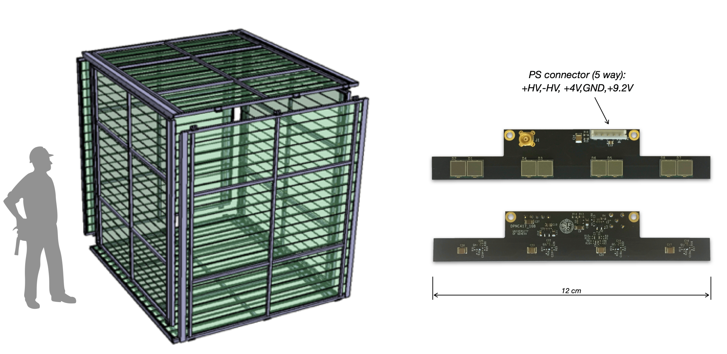
Figure 1: Left: 6 TOF modules assembled in cube. Right: front and back side photo of an amplifier board DPNC417_10B with 8 SiPMs. The boards are mounted to both ends of each bar.
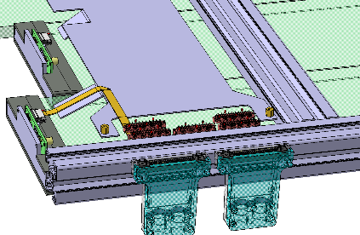
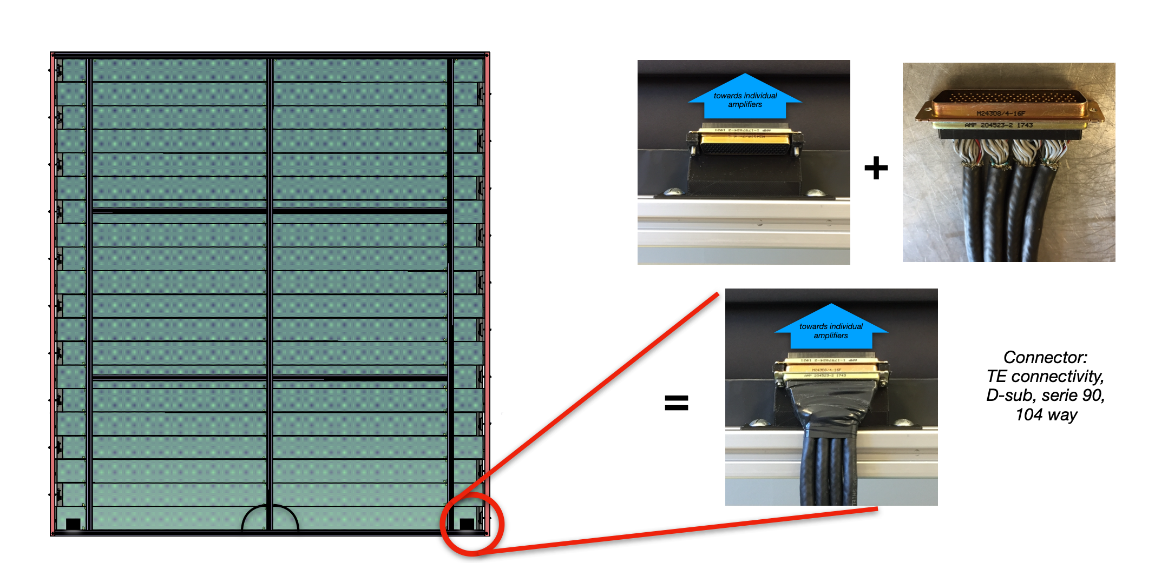

Figure 2: Left: one TOF module (20 bars = 40 readout channels) with two power connectors at the bottom. Right: CAD drawing with the 5 MICROMATCH (red in transparency) connectors of the module patch panel and the 2 x 50 pins Samtec ISDF-25-D-S connectors with a custom housing (blue) which will provide through ribbon cables (yellow) the HV+LV voltages to the 20 amplifiers of one side of the module from S/C minicrate.

Slow Control and Power Supply
The schematic representation of the slow control power supply (SCPS) and slow control system (SCS) is show in Figure 3. Two crates which distribute the voltage between the amplifiers are located inside the ND280 basket, thus in the magnetic field environment. While the DC power supplies and computer are ~20 m away from the basket.

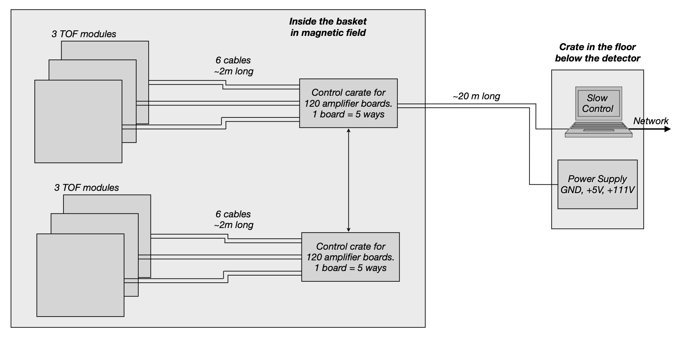
Figure 3: Schematic representation of the power supply and slow control system. Two crates which distribute the voltage between the amplifiers are located inside the ND280 basket.
The hardware architecture of the SCPS&SCS is defined as follow:
- 2 SCS crates will be located inside the basket (in magnetic field). Each crate must supply and control 3 TOF modules = 6 power connectors = 120 amplifier boards.
- All power input voltages for the crates will be supplied from outside the basket from SCPC:
  - 5V/5V return and 2 sense wires (crate’s power).
  - 4V/4V return and 2 sense wires (LV amplifier, transistors)
  - 9.2V/ 9.2V return and 2 sense wires (LV of amplifier, OPA)
  - HV/ HV return (111V SiPM bias)
- Characteristics of the SCPS:
WIENER Multichannel Low Voltage Modules will provide the above-mentioned power to the SCS.
- An MPV8120H module will provide the SIPM bias (111V). The module has 8 channels can supply voltages up to 120V with 100mA maximum current, with a peak power of 12W/ch, <2mVp-p ripple.
- A MPV8016I will provide the 4V and 9.2 V voltages for the amplifiers and the 5V for the SC crates. This module has also 8 channels and can supply voltages up to 8V and 5A max current with a peak power of 50W/ch and <2mVp-p ripple
All channels in the WIENER modules are individually controlled, floating and sensed, with programmable trip points, ramps, failure action and group behavior. Voltage and current settings and monitoring for each channel have 15-bits resolution for the standard series (MPV8016I) and 21-bits for the High Precision Series (MPV8120H). The modules will be hosted in a 19” minicrate hosting up to 4 modules The MPOD mini crate includes the primary power supply with 600W power for high voltage modules as well as a cooling system with high performance DC fan. Ethernet, USB and CAN-bus interfaces are available for remote connection and control.

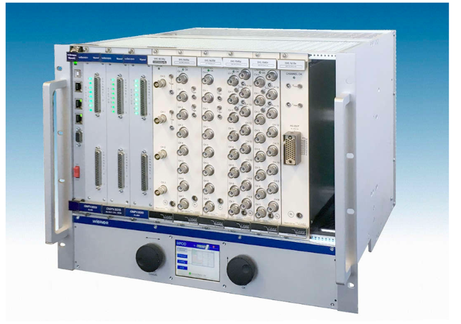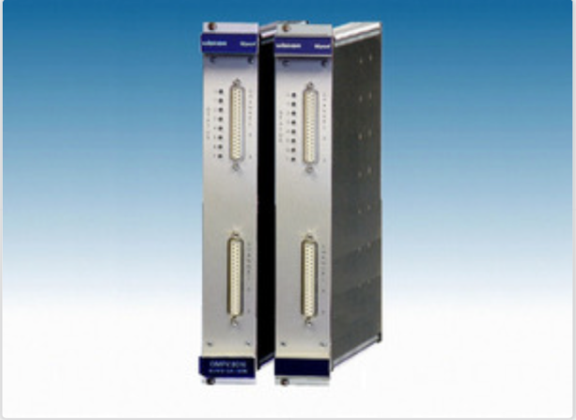
Figure 4: SCPS WIENER minicrate (left) and modules (right)

- Characteristics of the SC system:
  - One SCS mini-crate contains 10 Slow Control Boards (SCB) which communicate via a backplane through a CAN bus where each backplane slot corresponds to a dedicated CAN bus address (Figure 5, Left)
  - SC mini-crate size: VME 3U 22 cm x 13 cm x 19 cm (width x height x depth)
  - The SCB controls 12 amplifiers, i.e. 10 x 12 = 120 amplifiers per crate, the size of the SCB is approximately 10 cm x 17 cm with a pitch of 22mm between the boards in the crate. (Figure 5, Right)
  - The maximum power consumption of one amplifier is 0.3W i.e. 120 x 0.3 = 36W to be provided per crate (typically 6mA on 9V2 and 35mA on 4V, i.e. 200mW per amplifier)
  - The backplane contains 12 x 50 pins TFM-125 power connectors for the amplifiers (Figure 6) and they have a good 360° shielding connection for EMC due to a custom casing made by unige, an EMC conductive seal and a gold area for the seal on the backplane PCB (Figure 6). Each connector provides power to 10 amplifiers with 5 pins per amplifier (9V2, 4V, LVGND, HV, HVGND) thanks to a custom 50 wires shielded cable (Figure 7) connected on both ends to the ground, i.e. on the backplane side and on the module patch panel side (Figure 8).
  - On the backplane, a DSUB 25 pins male connector for the PS input voltages and a DSUB 9 pins female for the CAN signals will be used. They both have naturally a good 360° shielding connection for EMC (Figure 6)
  - The SCB integrates a 12-bits DAC for individual SiPM gain adjustment by modification of their operating voltage in a range of 8V with the externally supplied 119 V voltage, having a SiPM range of 109-117V with 1.85mV resolution. Adjustment of the offsets are done at the SiPM cathode (+HV). This gain adjustment is set through the CAN bus
  - The measurement of each channel bias voltage is made by a 16-bit ADC (1.84 mV resolution) on the SCB. This measurement is available through the CAN bus
  - All LV (9V2/4V) and HV individual amplifiers can be switched on/off remotely by the SCB through the CAN bus
  - The SCB integrates several temperature sensors and temperature interlock (software and hardware) to account for possible failures of the cooling system:
    - One temperature sensor per board
    - Software interlock that will trigger an alarm at the Slow Control computer and switch off all 12 LV and HV immediately. NB: Calibration will probably be needed
    - Hardware interlock with a fixed threshold is set to the conservative temperature level. When triggered, it will switch off the external power supplies through an opto-coupler. Several boards opto-coupler can be put in series having a redundancy
    - 2 NTC inputs (audio stereo 3.5mm jack) from the Front-Panel in order to connect 2 NTCs located on the module side. The temperatures for these NTC are available on request through CAN bus. NB: Having 10 boards in a mini-crate connected to 3 modules, this means 20 NTCs / 6 sides = 3 NTC per module side.
  - The SCB will consume ~50mA under 4.5V (225mW), i.e. 2.25W per mini-crate. No special cooling system but natural convection will be used to the small amount of power induced by the crate itself.

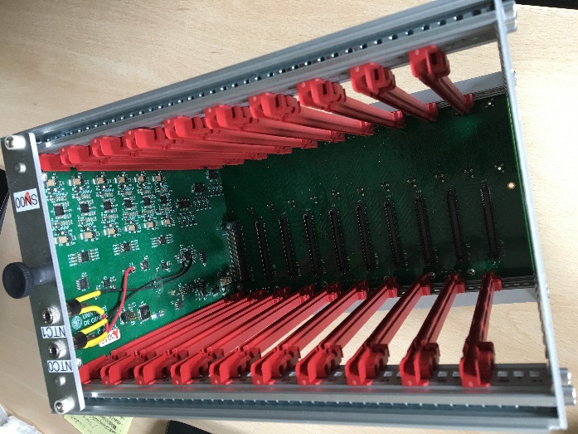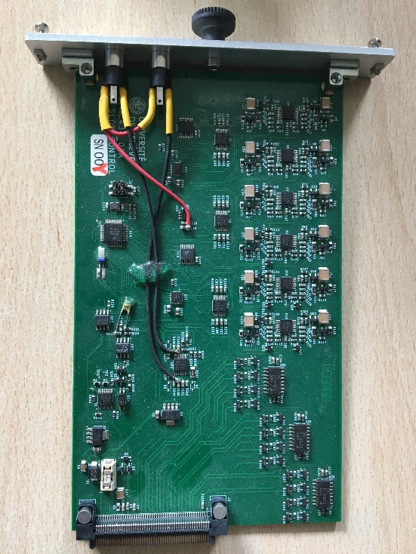
Figure 5: Left : 10 slots SC mini-crate with inserted SCB. Right: SCB board top view
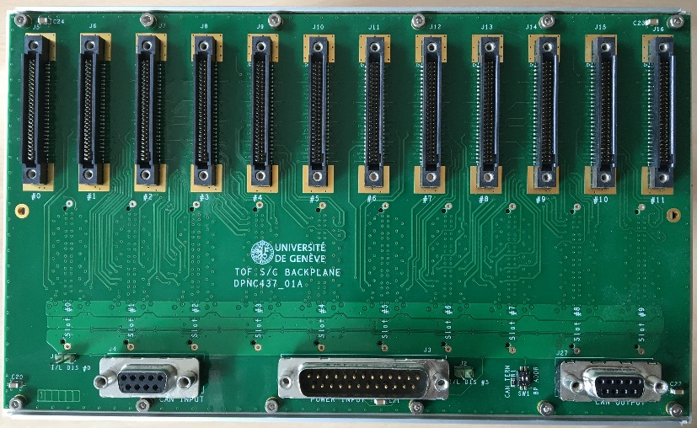
Figure 6: Rear side of the backplane with 12 x 50 pins connectors on the top and SUB-D connectors for CAN bus and PS on the bottom
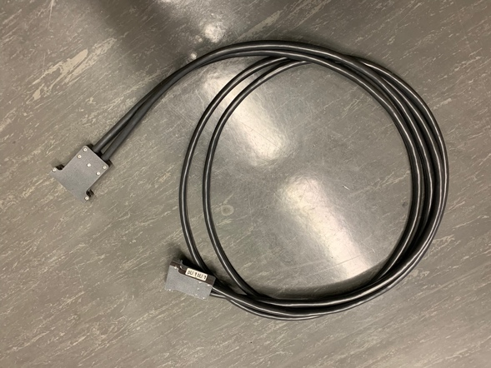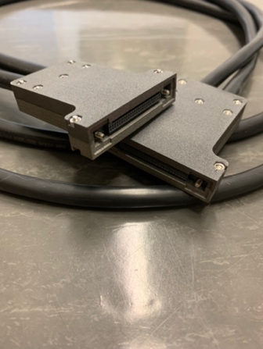
Figure 7: cable and connectors from the module patch panel and the SC crates

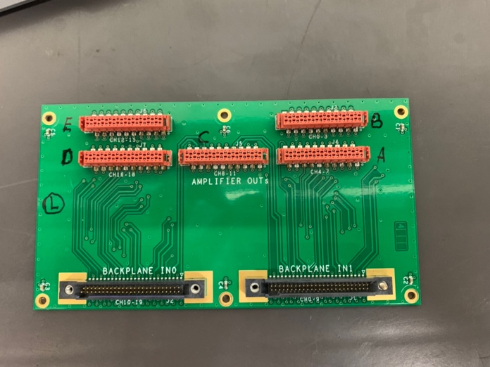
Figure 8: Patch panel mounted on each side of each ToF module. The black Backplane IN connectors link the SC crates and the power lines mounted on the module. The red Amplifier OUT connectors link to the HV/LV flat cables which connect to the SiPM arrays located at each side of the bar

DAQ system
The analog signal coming from the SiPM arrays is digitized using a Waveform and Time to Digital Converter (WTDC) multichannel chip called SAMpler for PICosecond time pick-off (SAMPIC) designed and produced by the Laboratoire de l’Accelerateur Linéaire (LAL) in Paris . The system is composed by 4 boards hosting each four 16 channels chip.

Each of the 256 channels associates a DLL-based TDC providing a raw time with an ultra-fast analog memory, allowing fine timing extraction as well as other parameters of the pulse. Each channel also integrates a discriminator that can trigger itself independently or participate to a more complex trigger. After triggering, analog data is digitized by an on-chip ADC and sent serially to the DAQ. A waveform is finally provided in the form of an array of samples containing the value of the voltage. At the same time, the Time-Over-Threshold can be measured and stored independently, even covering a larger time window than the waveforms. A Constant Fraction Discrimination function is included as well.
The default board design foreseen DC-DC converter which for our case have been replaced by LDO converter to avoid any possible issue while running in the magnetic field.
The SAMPIC can record data with a sampling rate up to 6.4GHz but for the ToF will be operated at 3.2GHz which gives a recorded window of 20ns.

Dominique & JIhane : Add here a more detailed description of the boards, controller and backplane, their G&S
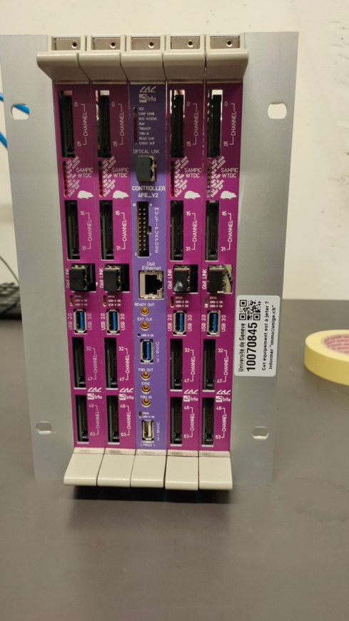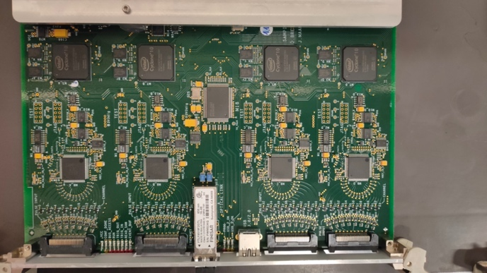
Figure 9: Left : The four SAMPIC boards and its controller installed in the custom built crate. Right: picture of one of the SAMPIC boards. In each board, four 16 channel chips are mounted

Architecture of G&S
The concept of the TOF Grounding & Shielding architecture is the following (Figure ):
- All PS wires are connected to the GND at the load side and ensure a return current in the corresponding wire (no DC current returning from the structure)
- All signals are shielded with a cable shield connected on both extremities to chassis ensuring a low impedance path to ground for HF common mode noise

This leads to the following:
- The S/C backplane has 2 GND planes:
  - 1 GND plane where 4V_SC PS return is connected (orange wires). This plane serves as a reference for the 4V_SC for the S/C boards and for the HV PS signals going to the amplifiers. The plane is connected to the crate chassis through capacitors in order to avoid HV return through the structure via the amplifier coaxial cable and the SAMPIC crate. The chassis should be connected to the detector frame
  - 1 LVGND plane for the amplifier LV PS signals (+9.2V & +4V blue/green) return wires. This LVGND plane is DC insulated from the Backplane GND Plane, but AC coupled with capacitors to provide a solid reference for HF common mode noise rejection (low impedance path to chassis
- The S/C boards have 2 GND planes:
  - 1 GND plane connected to the backplane GND plane with multiple points on the backplane connector. This handles digital & analog functions of the board from 4V_SC, including HV regulation, referenced from this GND plane
  - 1 LVGND plane for the amplifier LV PS signals (+9.2V & +4V blue/green) return wires. This plane is connected to the backplane LVGND plane with multiple points on the backplane connector. This LVGND plane is DC insulated from the S/C board GND Plane, but AC coupled with capacitors to provide a solid reference for HF common mode noise rejection (low impedance path to chassis
- The S/C boards have:
  - their digital and analog ICs supplied by LDOs connected to the GND plane. These LDOs are supplied by the floating remote 4V_SC PS having the return wire connected on the backplane GND plane which is the same than the board GND plane
  - their LV enabling stages are made with optocouplers driven by diodes, transistors, and µC located on the GND plane side (previous item).
  - their HV PS connected to the S/C GND plane trough a PI filter made of 2 resistors and 1 capacitor. The 2 resistors increase the CM noise rejection. The resistor on the return wire is connected to the S/C board GND plane
- Shielding cables connected on both side to chassis are used for the PS to backplane connections
- Shielding cables connected on both side to chassis are used for the backplane to patch panel connections
- The patch panels (PP) have:
  - 1 LVGND plane for the amplifier LV PS signals (+9.2V & +4V blue/green) return wires
  - 1 GND plane common for all HV (the same than the backplane). This GND plane is DC insulated from the PP chassis, but AC coupled with capacitors to provide a solid reference for HF common mode noise rejection (low impedance path to chassis).
- Flat cables are used from PP to amplifiers and they are put in sandwich between aluminum plates connected to the detector chassis for shielding efficiency
- The amplifier:
  - has its HV signals connected to the amplifier GND plane through a PI filter made of 2 resistors and 1 capacitor. The 2 resistors increase the CM noise rejection. The resistor on the return wire is connected to the amplifier board GND plane
  - has the return signal for LV (LGND) connected to the GND plane of the amplifier
  - is insulated from the chassis
  - has a coaxial output for the SiPM amplified signal. The MCX coaxial jack is connected to the amplifier GND plane
- The digitizer crate:
  - is composed of several SAMPIC boards supplied by a floating PS having its return wire connected on the SAMPIC side
  - has a GND plane connected to the chassis through the crate
  - has 16-ch input adapter boards having the same GND plane than the SAMPIC boards through the QRM8/QRF8-026 2x26 pins connector (16 signal + 36 GND pins). The coaxial cables carrying the input signal have their shielding braid directly tied to the adapter/SAMPIC GND plane. The amplifier GND plane is thus connected to the SAMPIC GND plane
  - has 50Ω AC coupling inputs. HF return current of the SiPM amplified signal is guaranteed to return in the coaxial cable due to lower inductance path in the coaxial braid than in the structure.
- Shielding cables connected on both side to chassis are used for the PS to digitizer crate connections
- This scheme ensures DC return currents for HV and LV completely controlled in the wires and not by the chassis or the structure:
  - LV +4V and +9.2V are completely DC insulated from the PS up to the amplifiers
  - Global HV is completely DC insulated from the PS up to the S/C boards
  - Amplifier HV is completely DC insulated from the backplane up to the amplifiers

Figure 11: Left : TOF G&S architecture

- Integration Considerations
As noted above, the TOF panels complete a nearly hermitic cage around the HATPC and the sFGD detectors and there is no access to the on-detector electronics for those devices. The cables for the HATPC and the sFGD which exit through the bottom of the system on beam left and beam right edges of the TOF bottom plate which is not quite hermetic. Therefore it is highly likely that we will need a patch panel or junction box somewhere just below the basket where short “pigtail” cables from at least the HATPC and sFDG (what does the TOF need??) connect to the long cables that go from this junction region down into the racks on the SS level. It is important that this patch panel observe the basic rules noted above for the overall cabling system:
- Pigtail cables connect to the proper long cable – we need a good labeling system
- Ground wires or shields on the pigtails connect only to their counterparts on the long cables – “ground” on one cable should not connect to “ground” on another cable even if they are connected together at the HATPC or sFDG electronics because that would create a loop which could act as an antenna for EMI

Conclusions

There seems to be a small probability that the timing/trigger link from MCM to SCMs to detectors can miss pulses and this may be due to imperfections in the treatment of grounds and/or signals on those links.

